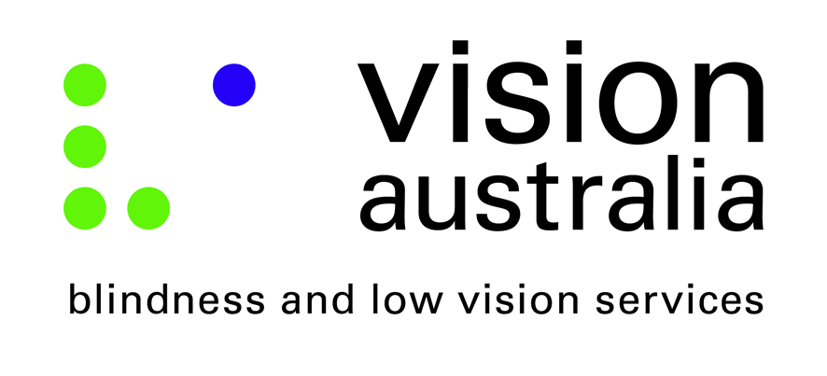

Vision Australia Submission in Response to Auditor General Report 18 (Qualifying for the Disability Support Pension)
Submitted to the Joint Committee of Public Accounts and Audits

Authorised by Karen Knight, General Manager Advocacy and Engagement, Vision Australia

Submitted on Monday 7 November 2016

Further information: Janet Renew, Advocacy Advisor
07 3727 2326 or janet.renew@visionaustralia.org or Kate Begley, Policy Advisor 03 9864 9415 or kate.begley@visionaustralia.org

Introduction
Vision Australia welcomes the opportunity to make a submission to the Inquiry into the administration of the Disability Support Pension (DSP) based on the Auditor-General’s report 18 (2015-16) (Qualifying for the Disability Support Pension).
The substance of this submission, including the recommendations that are offered, is derived from our experience interacting with people of all ages across Australia who are blind or have low vision. There are approximately 357,000 Australians who are blind or have low vision.
Based on the report, we provide our recommendations on the assessment of eligibility of the DSP, and reviewing ongoing recipient eligibility.

The DSP and people who are blind or have low vision
Disability incurs significant ongoing and unavoidable non-optional costs that other sections of the community are not subject to. This implies that the social security system should have effective ways of assessing these costs and ensuring that they are met adequately, in addition to providing income support to meet the costs that all people face.
The Disability Support Pension (DSP) is one way that the social security system can ensure people are supported to help meet these costs.
The non-optional costs incurred by people who are blind or have low vision include:
- the costs of paying for basic home maintenance and repairs, lawn mowing, gardening and landscaping, etc., that a sighted person could choose to do themselves;
- the costs of travel and mobility, including upkeep of a Seeing Eye Dog (food, veterinary expenses, etc.), and/or paying for taxi trips;
- the extra costs (higher rent, higher council rates, higher home purchase prices, etc.) of living in an area with good infrastructure such as public transport, schools, child care facilities, libraries, and shops (since people who are blind or have low vision are unable to drive to such facilities);
- the costs of paying for medications and medical equipment that is not subsidised, such as some eye-drops, sunglasses and contact lenses;
- costs associated with parenting, such as paying for tutors to assist children with difficult homework or subjects, because a person who is blind or has low vision cannot read their children’s school textbooks to provide assistance themselves.
Pensions and allowances should be used to cover these as well as general costs, and it is left up to the individual to figure out how or whether this can be done. Vision Australia considers the DSP to be essential to ensure people who are blind or have low vision can meet these costs and participate fully in community life.
When the National Disability Insurance Scheme (NDIS) is fully implemented, some of the non-optional costs of blindness and low vision may be funded, such as the costs of adaptive technology to access information. However, many other non-optional costs will not be funded, and further, many people who are blind or have low vision will not be eligible for the NDIS. This reiterates the importance of the DSP in meeting these costs.

Assessment of eligibility for the DSP
We understand that a person whose medical evidence clearly indicates that they have permanent blindness is accepted as being manifestly eligible for DSP (Blind). A report from an ophthalmologist or optometrist (with the supporting ophthalmologist’s details) is sufficient medical evidence to support an application. Under social security law, if a person is considered manifestly eligible due to permanent blindness they are not required to take part in any other assessments, including Job Capacity Assessments.
RECOMMENDATION 1 - Vision Australia recommends that the manifest eligibility criteria for the DSP be retained.
In providing services to clients, we are aware of instances where people understand themselves to be recipients of DSP (Blind) and as such are exempt from assessments, but are nevertheless asked to participate in various assessments. This may be due to a lack of understanding of manifest eligibility, and we recommend the Department ensure that recipients and potential recipients are consistently informed about their entitlements and obligations to avoid unnecessary administrative burden or personal hardship.

Reviewing ongoing DSP recipient eligibility
An ophthalmologist report that includes information about the diagnosis, treatment, symptoms, functional impact and prognosis of an applicant’s vision is required and sufficient to meet the criteria for the DSP (Blind). Additionally, evidence of permanent blindness is required to satisfy criteria for manifest eligibility.
RECOMMENDATION 2 - Vision Australia recommends that the current criteria for permanent blindness be retained. We consider the ophthalmologist report to be sufficient evidence to prove ongoing DSP recipient eligibility and recipients who have sufficiently met these criteria should not be subject to further review.

About Vision Australia
Vision Australia has gained unrivalled knowledge and experience through constant interaction with our 27,500 clients and their families, and also through the involvement of people who are blind or have low vision at all levels of the organisation. Vision Australia is therefore well placed to provide advice to government, business, and the community on the challenges faced by people who are blind or have low vision fully participating in community life.
We have a vibrant client consultative framework with people who are blind or have low vision representing the voice and needs of clients of the organisation to the Board and Management.

